Sterilization by Design: Gender, Class, and Legislative Intent at the Keller Institution 1930–1943

Introduction
Problem, orientation and motivation
This paper investigates sterilisation in Denmark in the years 1930-1943 following the sterilisation laws from 1929, 1934 and 1935 to understand the significance of the laws impact on society. This paper asks the question of to what extent did the introduction of the 1934 Sterilization Act systematically target women and lower social classes at the Keller Institutions for the feebleminded in the years 1930–1943? My motivation stems from the topic's continuous relevancy today, and how it forces us to reflect on how science and legislation can be misused to marginalize specific groups. By understanding how systematic abuses against women and the poor were justified in the past we become better equipped to recognize and counteract discrimination in modern society, whether it concerns the rights of people with disabilities or state surveillance of citizens. Using digitised archival sources from the Keller institutions, digital methods allow us to visualize sterilization practices over time and compare how the three legislative acts shaped their scope and severity.

Historical context
Denmark became the first European country to pass sterilisation legislation in 1929, emerging from a broader wave of social reform. The Social Democrat K.K. Steincke argued that eugenic measures and social welfare were complementary, believing the state could afford to be humane toward the unfit provided they did not reproduce. The 1934 Act removed the consent requirement entirely and allowed sterilisation to be initiated by institutional leadership without individual agreement, while the 1935 Act introduced compulsory castration and a formal eugenic indication. The existing scholarship on this topic is substantial. Historian Bent Sigurd Hansen demonstrates that the scientific basis for hereditary claims was contested even among the commission members who drafted the legislation, complicating any reading of the laws as purely rational policy. Birgit Kirkebæk shows through case file analysis that “feeblemindedness” functioned as a social and moral category applied disproportionately to poor and illegitimate women, with female sexuality systematically pathologized as a justification for institutionalisation. Heine Andersen’s review of Lene Koch's research further establishes that the voluntary character of the 1929 law was largely nominal given institutional pressures, and that approximately 6,000 of Denmark's 13,000 total sterilisations fell under the 1934 Act alone. This study builds on these findings by quantifying the demographic patterns these scholars describe.
Hypothesis
In my findings I expect to see a statistical trend pointing towards a systemic targeting of women and those from lower social classes, furthermore I expect to see a rise in sterilizations from 1934 onward due to the radicalisation in the 1934 sterilization law change.

Methods
Research design
This study adopts a quantitative, nomothetic research design to identify gender- and class-based patterns in sterilisation practices at the Keller institutions between 1930 and 1943. The analysis is based on digitised archival records, which are used to examine how the three sterilisation laws of 1929, 1934, and 1935 were implemented in practice. The study compares observed patterns in the data with the stated intentions of the legislation, thereby assessing discrepancies between policy and practice — in particular, whether the 1934 Act produced a measurable and systematic shift in who was targeted for sterilisation.The research design is comparative across two dimensions: longitudinally, by tracking changes in sterilisation practice across the three legislative periods; and cross-sectionally, by comparing subgroups defined by gender, social class, age, and legitimacy of birth within each legislative framework. This dual structure allows the study to assess not only whether the volume of procedures changed following legislative reform, but also whether the demographic composition of those targeted shifted systematically — a distinction central to the research question.

Software/Framework
The analysis was conducted on a MacBook Air (M2, 2022, 8 GB RAM) running macOS 26.1. Data processing and visualisation were performed in R (version 4.5.2) using RStudio (version 2026.01.1+403). The primary packages used include tidyverse, readr, and dplyr for data manipulation and cleaning, ggplot2 and patchwork for visualisation, and scales for axis formatting. The complete annotated script is deposited in the project's GitHub repository and is fully reproducible.
Data / processing
The dataset used in this study was sourced from “kilderne.dk”, a digitised archive of historical primary sources drawing on records held at the Danish National Archives (Rigsarkivet). The dataset, stored as Steri_fil.csv, contains 500 observations representing individual sterilisation and castration procedures carried out at the Keller institutions between 1930 and 1943. Each row corresponds to one individual, recorded across 11 variables as seen in the chart below. Upon import, the variables SterÅr (year of sterilisation) and Fødselsår (year of birth) were stored as character strings and required conversion to numeric format before analysis could proceed. One individual appears twice in the dataset due to a registration error present in the original archival source; this duplicate is identifiable by a letter suffix in the case number column and was retained as recorded, as it reflects the source material rather than an error introduced during processing. Cases with missing values in key variables were excluded listwise for each individual analysis but retained in the full dataset to avoid unnecessary data loss across figures where those variables were not required. When construction variables, a derived variable “Alder” (age at sterilisation), was computed as the arithmetic difference between “SterÅr “and “Fødselsår”. The legal basis variable (Lov) was recoded into a labelled factor with three levels corresponding to the 1929 voluntary act, the 1934 compulsory act, and the 1935 extended act, enabling consistent ordering across all figures. The social class variable (Hovedgrp) was treated as an ordered categorical variable with four groups ranging from Group A (highest) to Group D (unspecified/marginalised). No observations were removed from the dataset on substantive grounds. Exclusions were limited to cases where values required for a specific calculation were missing, for instance, cases lacking a recorded year of birth were excluded only from the age analysis. This conservative approach was chosen to maximise representativeness while avoiding the introduction of systematic bias through blanket exclusion. The analysis is entirely descriptive and visual, producing five figures that together form the empirical basis for the findings presented in the following “findings” section.

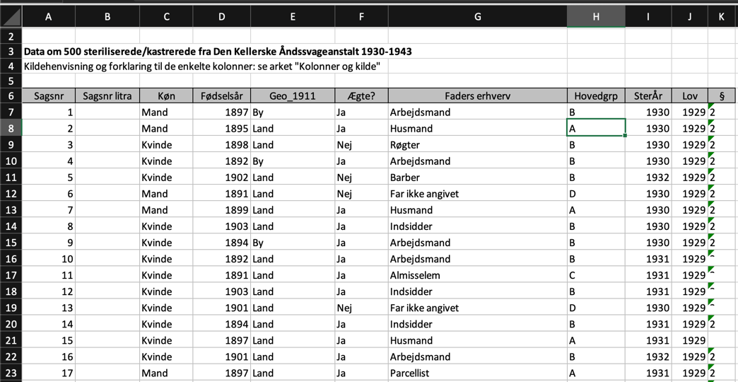

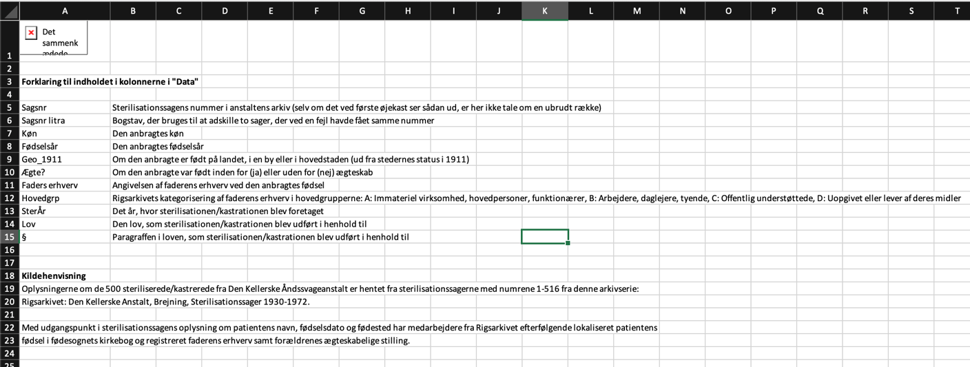

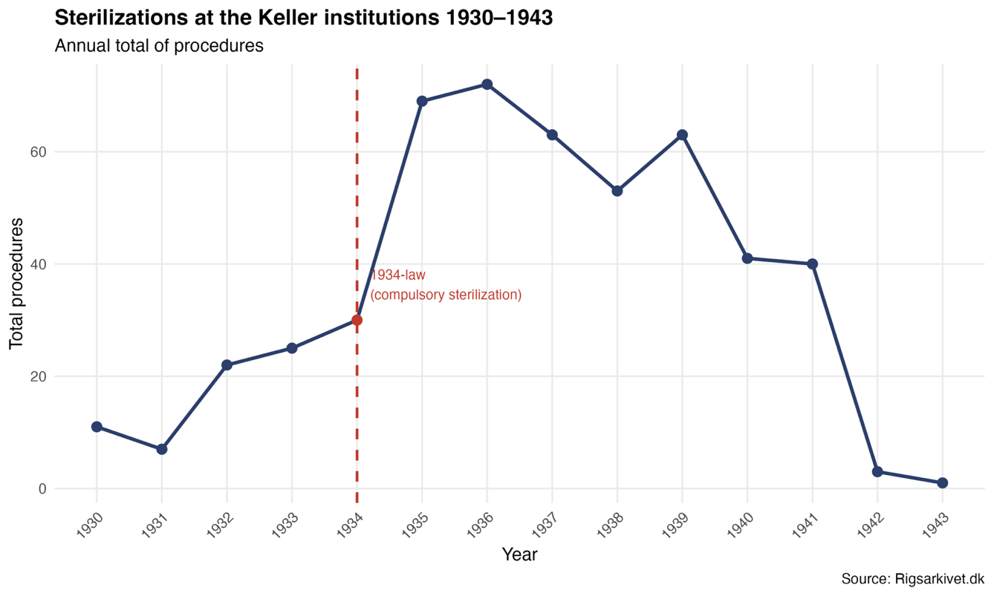
Findings 1 – 1,5 pages,
Figure 1:Annual number of sterilization and castration procedures at the Keller institutions, 1930–1943. The sharp increase following the introduction of the compulsory 1934 Act is clearly visible, with procedures peaking at 73 in 1936.x

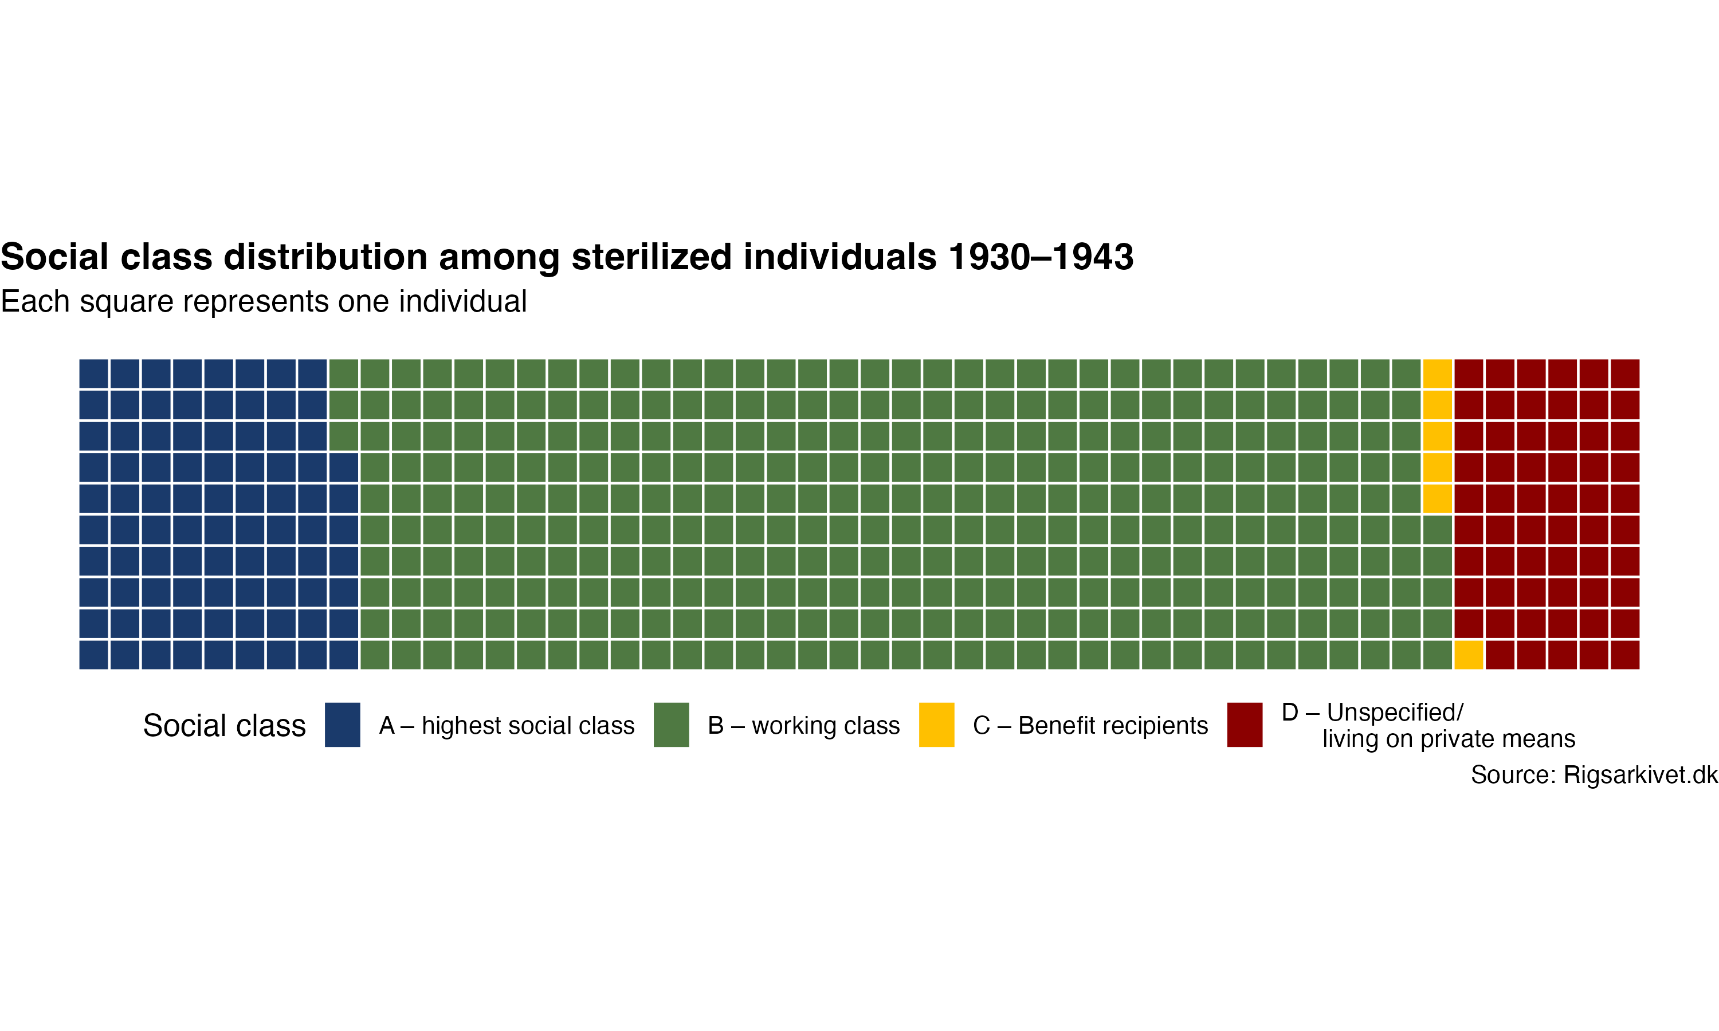
Figure 1 illustrates the total annual number of sterilization procedures carried out at the Keller institutions between 1930 and 1943. In the years preceding the 1934 Act, the number of procedures remained relatively modest, ranging from 7 to 30 per year. Following the introduction of the compulsory 1934 Act, however, a sharp and immediate increase is observable: the number nearly tripled within two years, peaking at 73 procedures in 1936. This dramatic rise strongly suggests that the 1934 Act was the primary legislative driver of sterilization practice at the institutions. After 1936, numbers decline gradually, with a particularly steep drop after 1941, possibly reflecting broader political and administrative changes as Denmark entered the later stages of the German occupation.

Figure 2Waffle chart showing the social class composition of all sterilized individuals at the Keller institutions (n=500). Each square represents approximately two individuals. Group B (working class) accounts for approximately 70% of all cases.

Figure 2 is a waffle chart illustrating, the social class composition of all sterilized individuals, where each square represents approximately two individuals. Group B, broadly corresponding to the working class, dominates overwhelmingly, accounting for approximately 70% of all cases. Group A, representing the highest social stratum, accounts for roughly 17%, while Groups C and D together make up the remaining share. The visual format makes immediately apparent how dramatically concentrated sterilization practice was among the lower social classes. This distribution supports the argument that the sterilization laws functioned not merely as medical interventions but as instruments of social control directed predominantly at economically marginalised populations.

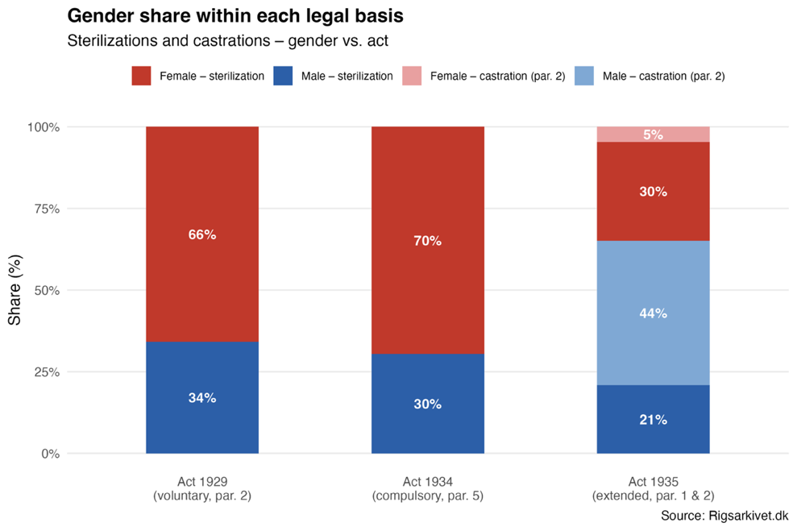

Figure 3: Gender distribution of sterilization and castration procedures under each of the three legislative acts (1929, 1934, 1935). Women consistently account for the majority of sterilizations across all three frameworks.

Displayed in the diagram of figure 3 is the gender distribution of sterilization and castration procedures under each of the three laws. Across all three acts, women consistently account for most sterilizations. Under the voluntary 1929 Act, women represented 66% of procedures; this share increased to 70% under the compulsory 1934 Act, indicating that the introduction of compulsory sterilization disproportionately targeted women. Notably, the 1935 Act introduced castration as a procedure, applied predominantly to men (44%), while women continued to account for most sterilizations (30%). The persistent overrepresentation of women across all three legislative frameworks supports the argument that gender was a systematic factor in how the sterilization laws were applied in practice.

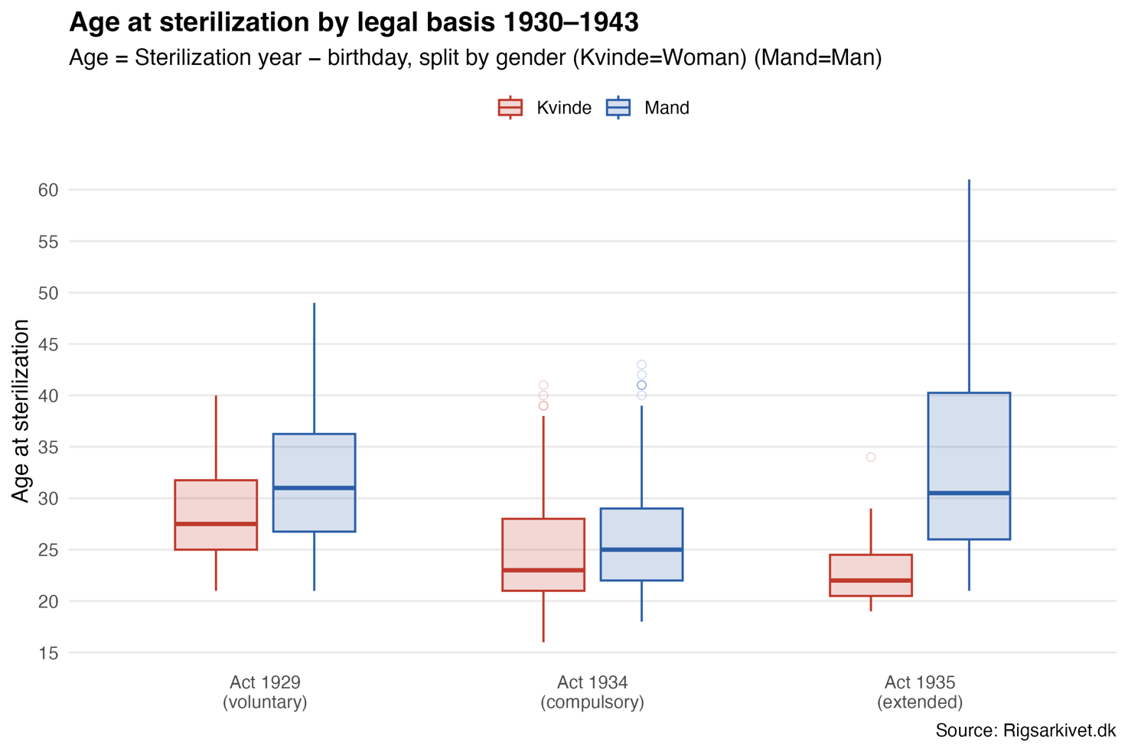

Figure 4: Box plots showing age distribution at time of sterilization for women and men under each of the three acts. The median age for women drops markedly from 27.5 years under the 1929 Act to 22 years under the 1935 Act, indicating increasing concentration within reproductive age brackets

Visualized is the age distribution of figure 4 at the time of sterilization for both women and men under each of the three acts. Under the voluntary 1929 Act, the median age for women was approximately 27.5 years, compared to 31 years for men. Following the introduction of the compulsory 1934 Act, the median age for women dropped markedly to 23 years, a decline of nearly five years, while the male median fell from 31 to 25. This shift is analytically significant: the tightening of the IQR for women under the 1934 Act suggests that procedures were increasingly concentrated within a narrow reproductive age bracket, pointing to a deliberate targeting of women's reproductive capacity. The 1935 Act shows a continuation of this pattern for women, with the lowest median age of 22, whereas men sterilized under
the 1935 Act show a considerably wider and older age distribution.

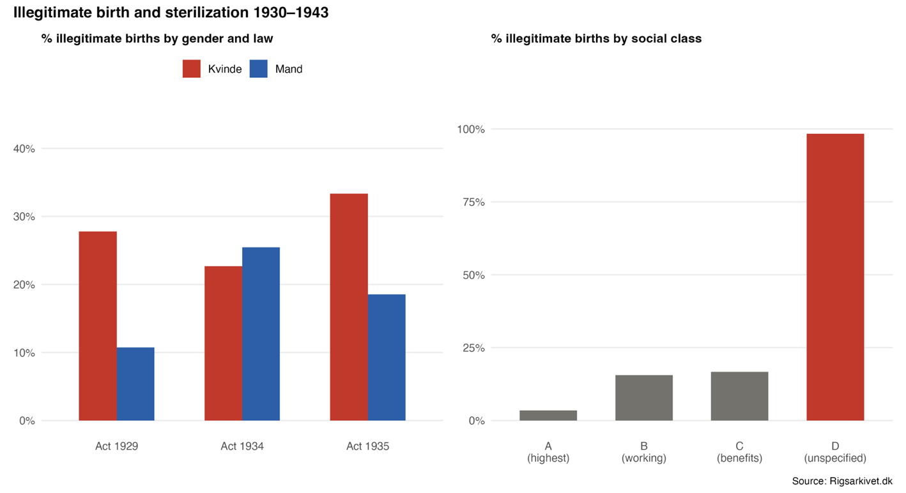

Figure 5: Left panel: Percentage of sterilized individuals born outside of wedlock, broken down by gender and legislative act. Right panel: Share of illegitimate births by social class group. Group D shows a near-total overlap (98%) between illegitimate birth an

Figure 5, examines the relationship between illegitimate birth and sterilization, presenting two complementary perspectives. The left panel shows the percentage of sterilized individuals who were born outside of wedlock, broken down by gender and law. Under the 1929 Act, women born outside of wedlock were notably overrepresented at 27.8%, compared to only 10.7% of men, suggesting that illegitimate birth carried a particular stigma for women that made them more vulnerable to sterilization. Under the 1934 Act, this gender gap narrowed considerably (22.7% vs. 25.4%), which may indicate that the compulsory law cast a wider net, reducing the relative weight of illegitimate birth as a gendered selection criterion. The right panel reveals an even more striking pattern at the level of social class: 98% of individuals in Group D, the lowest and most socially marginalised category, were born outside of wedlock. This near-total overlap between illegitimate birth and the lowest social stratum strongly suggests that illegitimate-born individuals in precarious social circumstances were systematically identified as targets for sterilization, intersecting vulnerabilities of class, gender, and social origin.

Discussion of results / Critical evaluation
Significance
The findings of this study provide substantial empirical support for the hypothesis that the 1934 Sterilization Act produced a systematic and demographically targeted shift in sterilisation practice at the Keller institutions. The data confirms the expected pattern across multiple dimensions simultaneously: gender, age, social class, and legitimacy of birth all align in a way that is difficult to explain as coincidental. The most significant finding is the convergence of these variables around a specific social profile. The individuals most heavily targeted were young women, born outside of wedlock, from the working class or below, originating predominantly from rural areas. Under the voluntary 1929 Act, sterilisation practice was already skewed towards women, 66% of procedures, but the introduction of the compulsory 1934 Act both intensified and narrowed this targeting. The female median age at sterilisation dropped from 27.5 to 23 years, concentrating procedures within the most reproductively active years of women's lives. This is not a marginal statistical shift; it represents a deliberate reorientation of the legislation's practical application towards the prevention of reproduction among a specific demographic group. The social class findings reinforce this conclusion. Group B, broadly corresponding to the working class, accounts for approximately 70% of all sterilised individuals, while Group D, the most economically marginalised category, shows a near-total overlap with illegitimate birth at 98%. This suggests that the sterilisation programme functioned as an instrument of social control directed at those least equipped to resist institutional authority, consistent with KK Steincke's stated ambition to police the reproductive behaviour of the lower classes. The data thus confirms that the 1934 Act did not simply expand the reach of sterilisation policy numerically, it deepened its class-based and gendered character.

Evaluation
The investigation largely confirms the original hypothesis. The expected rise in sterilisations following 1934 is clearly visible in Figure 1, with procedures nearly tripling within two years of the Act's introduction and peaking at 73 in 1936. The expected gender and class bias is equally well supported across Figures 2 through 5. In this respect, the study achieves its stated purpose: to demonstrate, through quantitative analysis of archival data, that the 1934 Act systematically targeted women and lower social classes at the Keller institutions. However, two important qualifications must be acknowledged. First, the data covers only the Keller institutions, which were specifically designated for the care of the “feebleminded”. This institutional context means that the population under study was already subject to a particular form of state surveillance and control before sterilisation procedures were even considered. The patterns observed therefore reflect not only the logic of the sterilisation laws themselves, but also the broader institutional framework within which those laws were applied. It is possible that sterilisation practices at other Danish institutions followed different patterns, and the present findings cannot be straightforwardly generalised to the national picture. Second, the comparison between the three legislative periods is somewhat uneven in terms of sample size. The 1934 Act accounts for 374 out of 500 observations, while the 1929 and 1935 acts account for only 82 and 42 respectively. This imbalance means that percentage-based comparisons across acts must be interpreted with caution, as small absolute numbers in the 1929 and 1935 groups can produce unstable proportions.

Utility/new avenues
The dataset's individual-level detail across gender, age, class, legal basis, and birth legitimacy enables a multidimensional analysis that aggregate statistics could not provide. Its digitisation via kilderne.dk makes it directly accessible and reproducible. The primary limitation is that the dataset captures only those institutionalised at the Keller institutions; individuals sterilised outside institutional care, or those with sufficient social capital to resist, are entirely absent. The patterns observed are patterns of those caught within the system, not a complete picture of who the legislation targeted. This study demonstrates that digital methods can contribute meaningfully to historical research on state abuse, enabling distributional analysis across multiple variables at a scale that close reading of case files could not achieve. Two avenues merit further investigation. The steep decline in sterilisations after 1941 remains unexplained by the present data; whether it reflects the German occupation, administrative disruption, or institutional resistance could be explored through parliamentary and administrative records. Additionally, the 98% illegitimate birth rate in Group D suggests that birth status functioned as a primary criterion for marginalisation, institutionalisation, and ultimately sterilisation, a relationship that a broader dataset linking multiple institutions with civil registration and poor relief records could begin to untangle.

Conclusions and recommendations
The findings provide a clear and converging answer to the research question: the 1934 Sterilization Act systematically deepened the targeting of women and lower social classes at the Keller institutions. Women were overrepresented under every legislative framework, and their overrepresentation intensified under the compulsory 1934 Act, with procedures increasingly concentrated within reproductive age brackets. The working class accounted for most sterilised individuals, and the most marginalised group showed a near-total overlap with illegitimate birth — confirming that the Act functioned as an instrument of social control along intersecting lines of gender, class, and birth status. The primary recommendation for future research is to extend this analysis to other Danish care facilities, which would allow for a more representative national picture, and to link the dataset to civil registration and poor relief records to illuminate the institutional pathways through which individuals came to be sterilised.

Bibliography
1929 - Lov om Adgang til Sterilisation, 130 Lovtidende § §1-2 (1929).
1934 - Lov om Foranstaltninger vedrørende Åndssvage, 171 Lovtidende § §5 (1934).
1935 - Lov om Adgang til Sterilisation og Kastration, 176 § § 1-2 (1935).
Andersen, Heine. “Racehygiejne og tvangssterilisation i Danmark”. Dansk Sociologi 26, nr. 1 (2015): 55–75. https://doi.org/10.22439/dansoc.v26i1.4992.
Hansen, Bent Sigurd. Something Rotten in the State of Denmark : Eugenics and the Ascent of the Welfare State. 1996. http://hdl.handle.net/10224/3617.
Kirkebæk, Birgit. “Sexuality as Disability: The Women on Sprog⊘ and Danish Society”. Scandinavian journal of disability research : SJDR 7, nr. 3–4 (2006): 194–205. https://doi.org/10.1080/15017410500246079.
Korsgaard, Ove. “K.K. Steincke var racehygiejniker og ophavsmand til velfærdsstaten”. Information, Dagbladet Information, 14. april 2023. https://www.information.dk/debat/2023/04/kk-steincke-racehygiejniker-ophavsmand-velfaerdsstaten.
Aarhus Universitet. “Folketingets forhandlinger om Lov om Foranstaltninger vedrørende aandssvage, 1934”. danmarkshistorien.dk, 2023. https://danmarkshistorien.lex.dk/Folketingets_forhandlinger_om_Lov_om_Foranstaltninger_vedr%C3%B8rende_aandssvage,_1934.

Required Metadata (does not count towards character/page limit) (18.965 characters, 7.9 pages)
Please fill in the right column column with the correct information about your digital resources, and leave the left columns as they are

Table 1 – Software metadata
Software metadata description | Please fill in this column
Permanent link to Github repository where you put your script(s), R project, and data | https://github.com/Digital-Methods-HASS/AU802180_Storkholm_Rasmus/tree/main/Final_project
Software License | MIT License
Data License | Creative Commons Attribution 4.0 International (CC BY 4.0)
Software versions, Installation requirements & dependencies for software not used in class | R version 4.5.2, RStudio version 2026.01.1+403. Packages: tidyverse, readr, dplyr, ggplot2, patchwork, scales. All packages installable via install.packages() in R.
If available Link to software documentation for special software (only relevant if you go outside the scope of class) | Not applicable — all software used is standard course software.
Support email for questions | Au802180@au.uni.dk

Table 2 – Data metadata (use the template below or create your own metadata table)
Metadata description | Please fill in this column
Steri_fil.csv | Sterilisation and castration records from the Keller institutions for the feebleminded, Denmark 1930–1943. Collected by the Danish National Archives (Rigsarkivet) and accessed via kilderne.dk. 500 observations across 11 variables: case number, gender, year of birth, geographical origin (1911 census), legitimacy of birth, father's occupation, social class, year of sterilisation, legal basis, and procedural paragraph.

1929 - Lov om Adgang til Sterilisation, 130 Lovtidende § §1-2 (1929).
“Folketingets forhandlinger om Lov om Foranstaltninger vedrørende aandssvage, 1934”, danmarkshistorien.dk, Aarhus Universitet, 2023, https://danmarkshistorien.lex.dk/Folketingets_forhandlinger_om_Lov_om_Foranstaltninger_vedr%C3%B8rende_aandssvage,_1934.
Ove Korsgaard, “K.K. Steincke var racehygiejniker og ophavsmand til velfærdsstaten”, Information, Dagbladet Information, 14. april 2023, https://www.information.dk/debat/2023/04/kk-steincke-racehygiejniker-ophavsmand-velfaerdsstaten.
Bent Sigurd Hansen, Something Rotten in the State of Denmark : Eugenics and the Ascent of the Welfare State, 1996, http://hdl.handle.net/10224/3617. s.29
1934 - Lov om Foranstaltninger vedrørende Åndssvage, 171 Lovtidende § §5 (1934).
1935 - Lov om Adgang til Sterilisation og Kastration, 176 § § 1-2 (1935).
Hansen, Something Rotten in the State of Denmark : Eugenics and the Ascent of the Welfare State. S.33
Birgit Kirkebæk, “Sexuality as Disability: The Women on Sprog⊘ and Danish Society”, Scandinavian journal of disability research : SJDR 7, nr. 3–4 (2006): 194–205. s.197
Heine Andersen, “Racehygiejne og tvangssterilisation i Danmark”, Dansk Sociologi 26, nr. 1 (2015): 55–75 s.56

